Practical Test

Students have 50 minutes to complete this test

No talking allowed

Use any appropriate software and address all the questions and requirements, complete as many sections as possible.

Graphic Creation 50 marks
Use your graphics package to create a poster advertising a ‘limited collector plate’ according to the following minimum specifications:

Save this file as XXXPLATE, replacing XXX with your surname.

- The size of image is 400 by 400 pixels, with the plate centred as shown
- The following text must appear on the poster
“Limited Edition Collector Plate - Fish by Night ”
- The plate is shaded with a gradient fill and will give the effect of a star filled evening sky
- The edge of the plate is gold
- At the top of the plate is a graphic of the moon, created by you.
In the centre of the plate is the graphic, FISHYJPG, which is shown below.
(f) Colour this fish in your school colours and give the fish a shadow.



(h) The text is shaped to bend with the plate

Save this file as XXXPLATE, replacing XXX with your surname.

4. Olympic Advert (20 marks)

In the lead up to the Olympics a local newspaper is running a competition offering its readers the chance to compete in a race at the official Olympic venue against some great Aussie legends.

Your task is to create a newspaper advertisement like the one shown. Make sure that you adhere to the following guidelines:

- The advertisement is 20cm wide and 10cm high.
- The title ‘run against Aussie legends’ is white on black.
- The graphic (bottom left corner) should be any appropriate graphic/clipart.
- The text below the title should wrap around the graphic.
- The question should be in bold.
- The fill-in coupon should have a border as shown.
- The newspapers address should be in bold.
- The layout of the advertisement should be as in the sample.
- Add your name in the bottom right hand corner of the advertisement.
- Spell check your document.
- Save your work as XXADVERT, replacing XX with your initials and print.

Save as: xxx olympic.doc to a folder title AIT2b Marking created by you in the AIT 2b Folder.

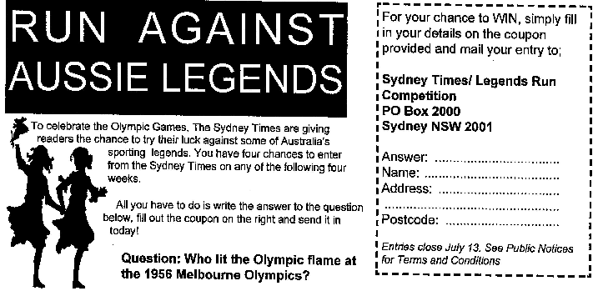

- Create a word document called
xxxevaluation.doc (xxx = your initials) 10 Marks

For each graphic explain how you created the graphic and describe any methods that you used, explain why you chose the software for each graphic and evaluate your own work

